FINAL PROJECT – APPLIED STATISTICS

Dataset:
url to Kaggle: https://www.kaggle.com/datasets/mirichoi0218/insurance

Medical Cost Personal Datasets
Dataset contains information about medical insurance companies' clients. It contains ~1300 rows, 7 columns: age, sex, bmi, children, smoker, region, charges

SQL queries on the dataset
Used:
- PostgreSQL (pgadmin + app itself)
- DBeaver
First I created table and imported data to it from the downloaded Kaggle dataset:
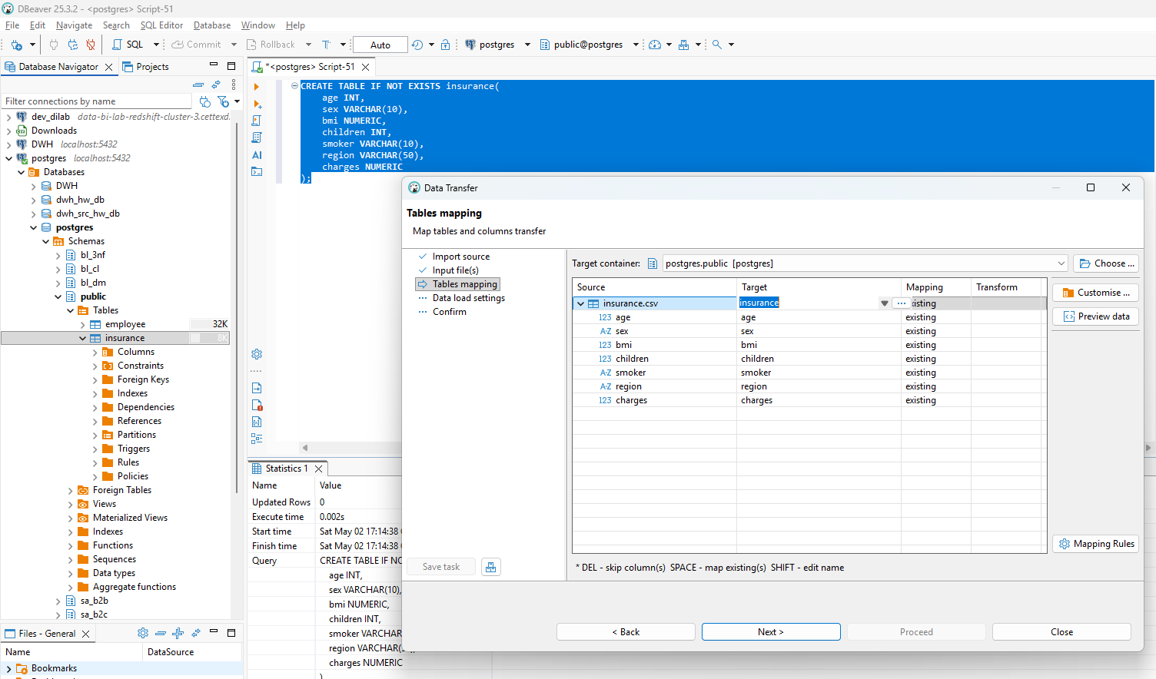

Tasks:
  - 5 basic queries (SELECT, WHERE, COUNT)
  - 5 aggregation queries (GROUP BY, AVG, SUM, etc.)
  - 1 query using CASE WHEN
  - 1 query using window function (OVER)

Basic queries:
Lets first check that data is consistent with data source:
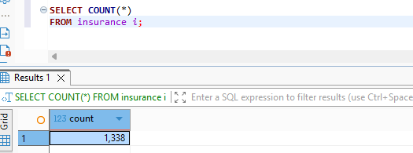
We have good split among sex:
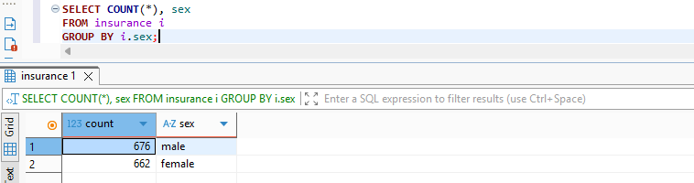
Most clients don’t smoke:
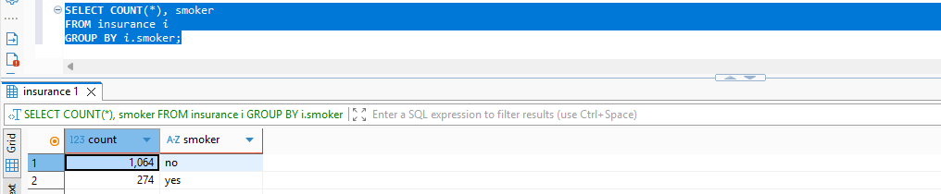
We have a good split among regions:
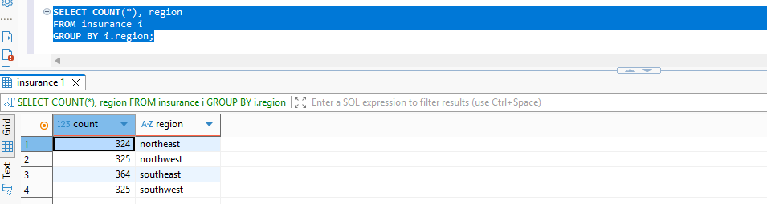
We have a lot of distinct BMIs in dataset:
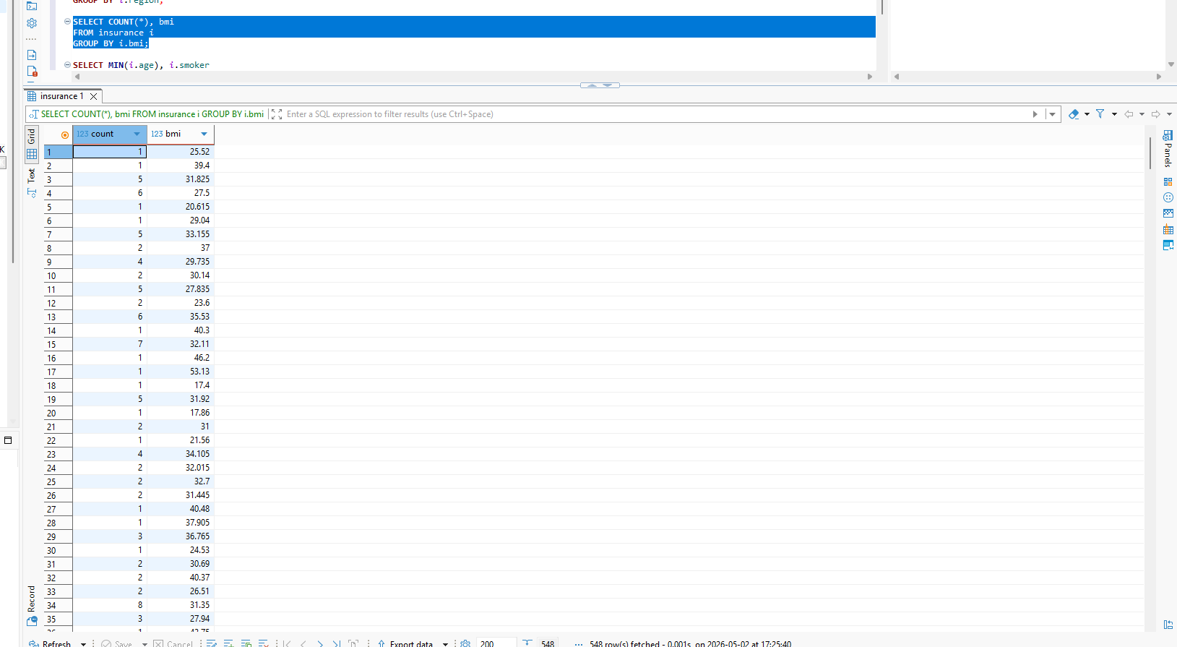
So in future we will make better query to understand the dataset.

Aggregation queries
Between smokers and non-smokers difference in mean age is only ~1 year:
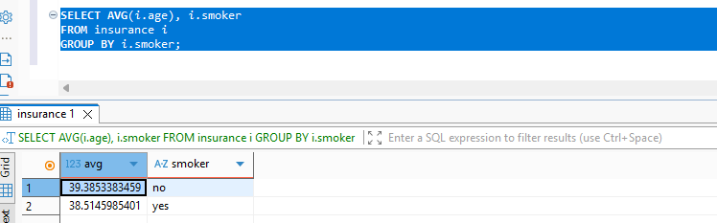
The oldest smoker and non-smoker have the same age:
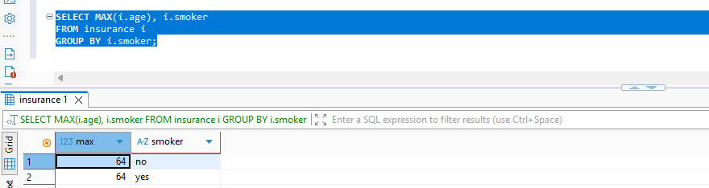
As well as the youngest smokers and non-smokers have the same age. That suggests that insurance company works only with adults (18+ years old clients)
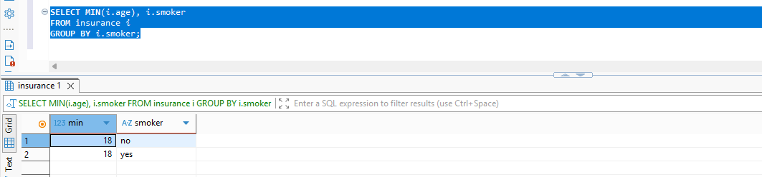

On average, smokers pay way more than those who don’t smoke:
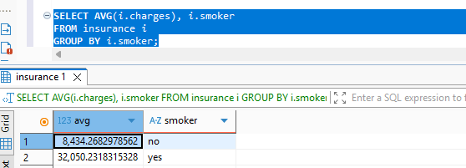
We see that generally there is a grow of charge with age:
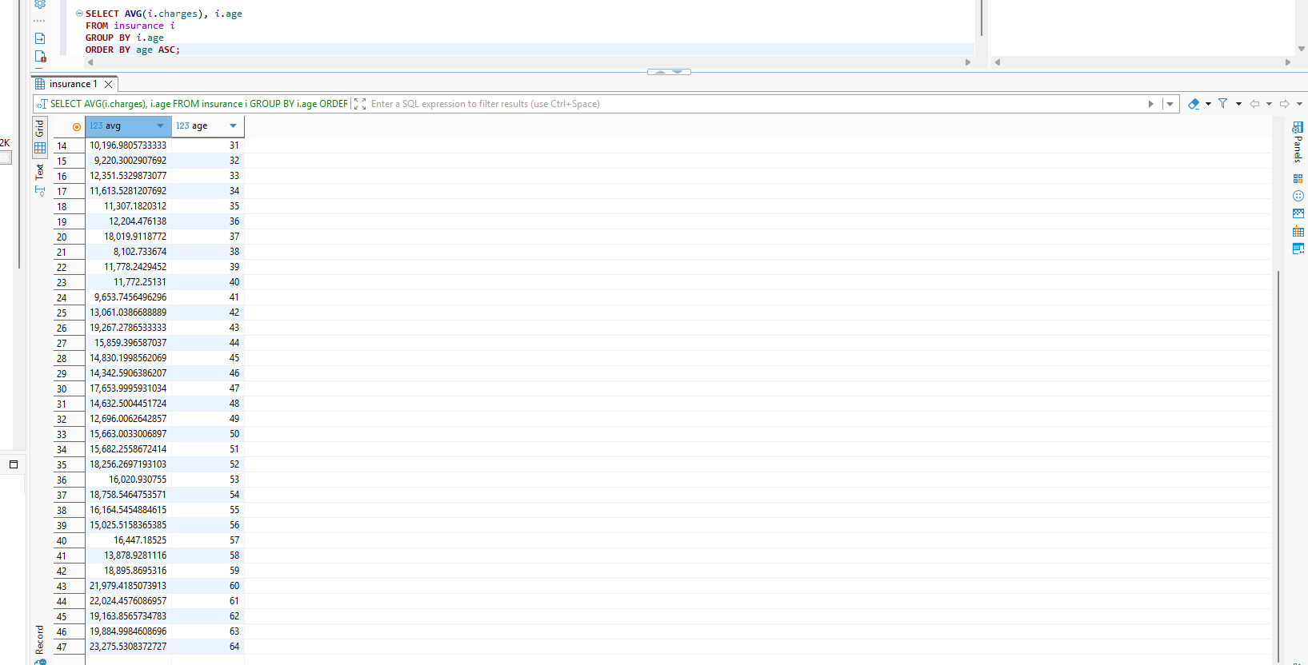
But here we see that MOSTLY (NOT ALWAYS) mean charge by age groups depends more on % of smokers in a group:
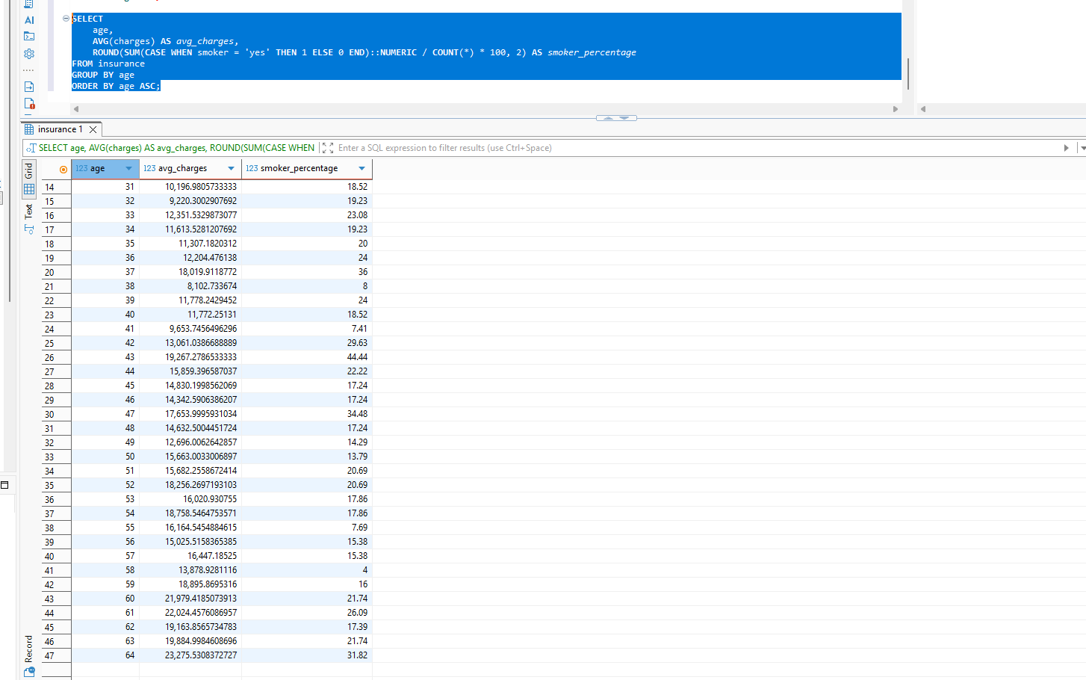

CASE WHEN
Well, previous query is both aggregation and case usage (because case helps a lot with avoiding CTEs for such complex aggregations), yet I wanted to create better BMI view so:
Underweight - Less than 18.5
Healthy Weight - 18.5 to less than 25
Overweight - 25 to less than 30
Obesity - 30 or greater
SOURCE: https://www.cdc.gov/bmi/adult-calculator/bmi-categories.html

So we will see how many people in each of those 4 groups:
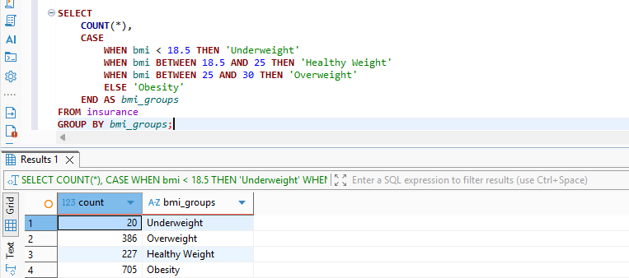
And now adding here previous smoker % finder, I believe there are no pattern here tho….:
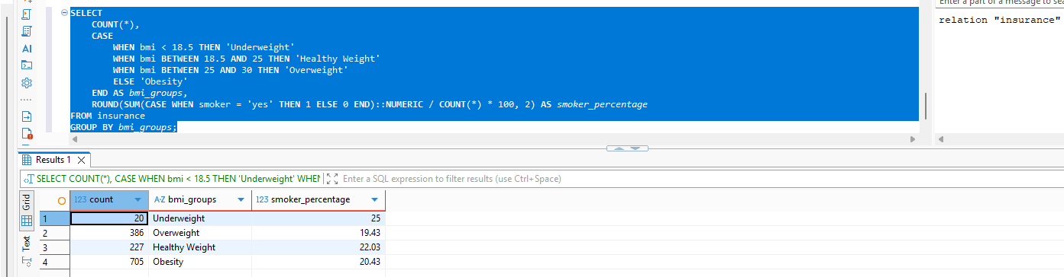

Window Function
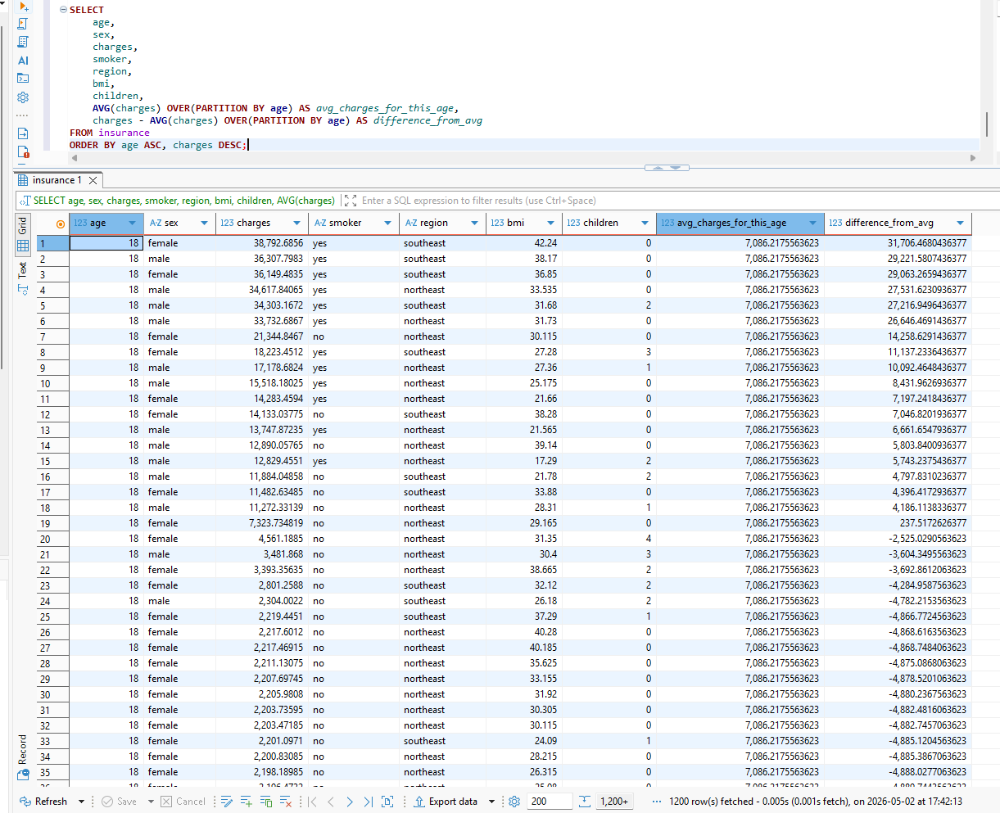
This query allows to see the difference between distinct person record’s charge and average to their age group (good for close observation of patterns :D)

Hope you liked those queries. As I am Data Integration Trainee I was happy to see SQL (and implementation of it in PostgreSQL and not MySQL (god forbid it’s usage in work)) and sad that this course wasn’t mostly about SQL :(

Python Notebook Work

2. Descriptive Statistics
- Compute:
  - Mean, median, standard deviation
- Compare at least 2 groups
Example:
- Average salary by gender
- Average rating by category

As for this task, I have already covered it with my SQL queries, yet there are to be done with the python:
It is easy to find statistics and differences using pandas
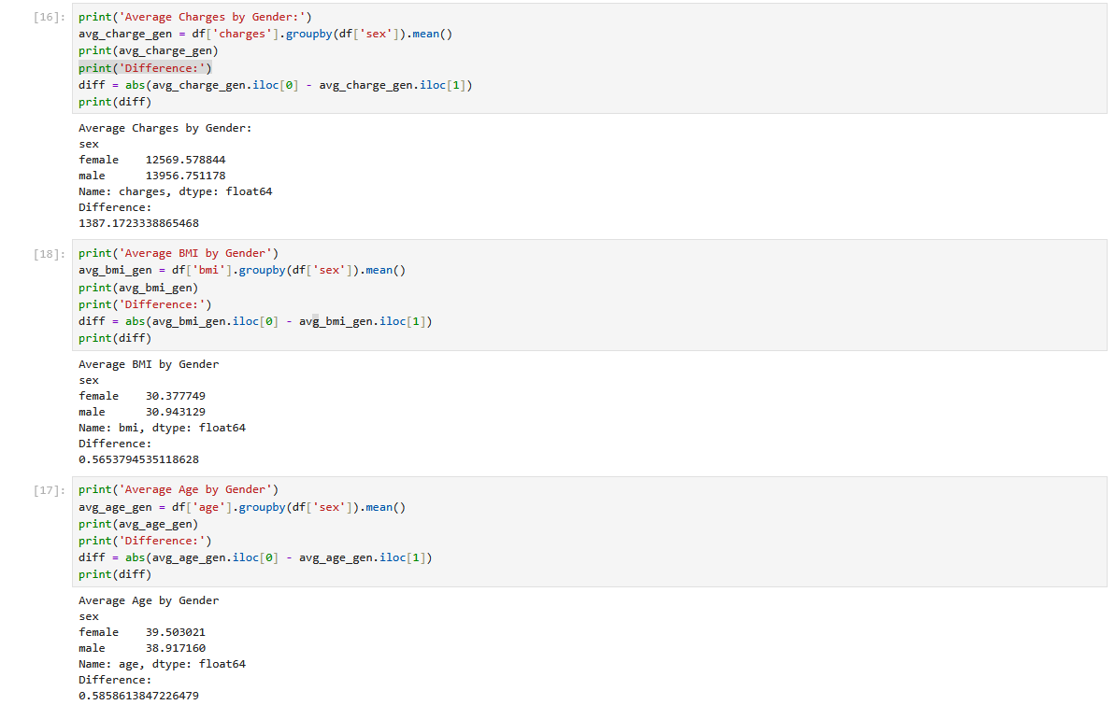
Those differences can be caused by the small size of the dataset, or they could be real. We will see in the future.

3. Probability Analysis
- Compute:
  - Empirical probability
  - Conditional probability
Example:
- P(Event)
- P(Event | Group)

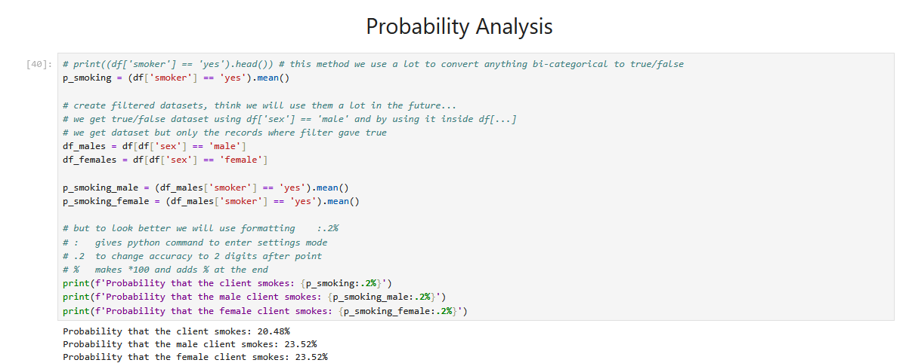

4. Sampling & Confidence Intervals
- Take random samples
- Compute:
  - Standard error
  - Confidence interval
- Optional: bootstrap

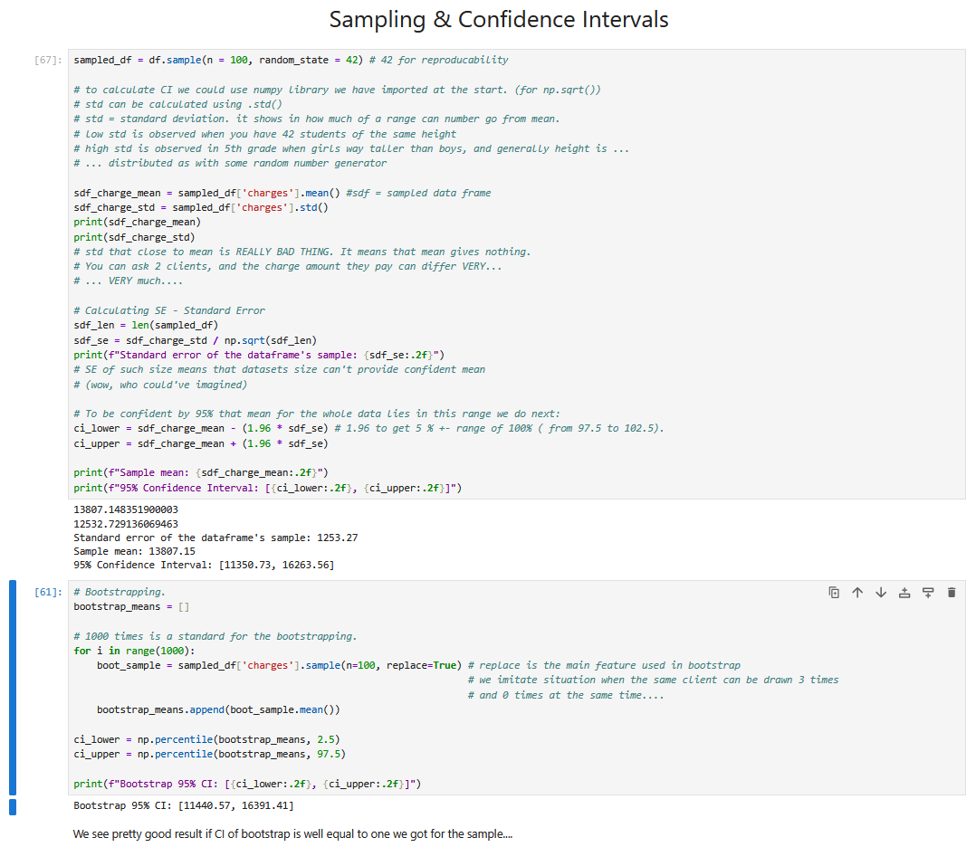
Well the dataset is more-likely robust, and gives pretty good results: the bootstrapped CI and one from the sample are quite the same.

5. Hypothesis Testing
- Perform at least one:
  - t-test OR
  - proportion test OR
  - permutation test
Must include:
- H₀ and H₁
- p-value
- conclusion
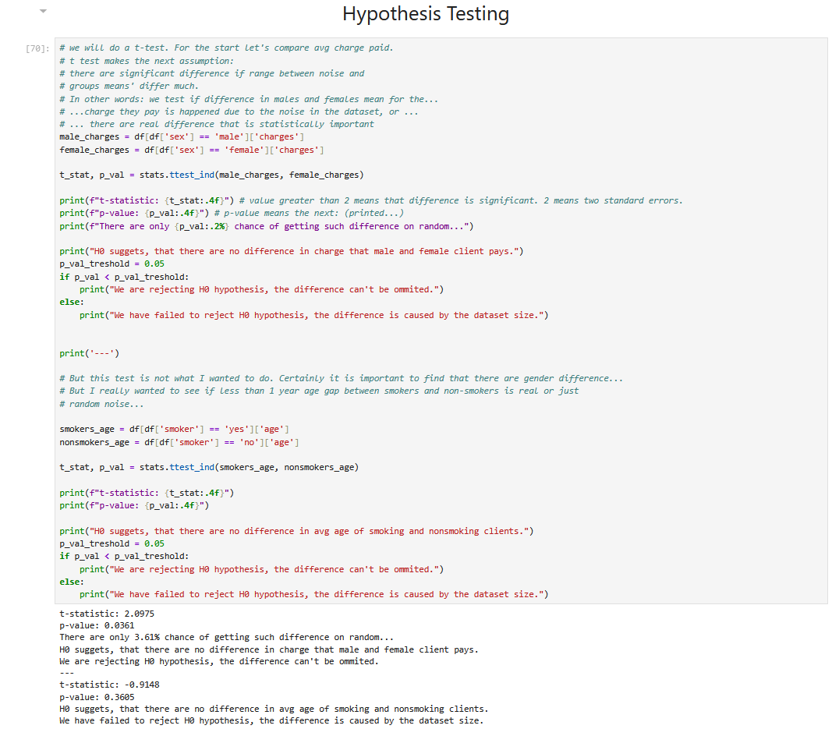
Conclusions:
Difference in the mean charge paid by female and male is caused by real, statistically significant reasons, while the difference in mostly 1 year in age of those who smoke and don’t is caused by the noise in the dataset.

6. Effect Size
- Compute Cohen’s d
- Compare:
  - statistical significance vs practical significance
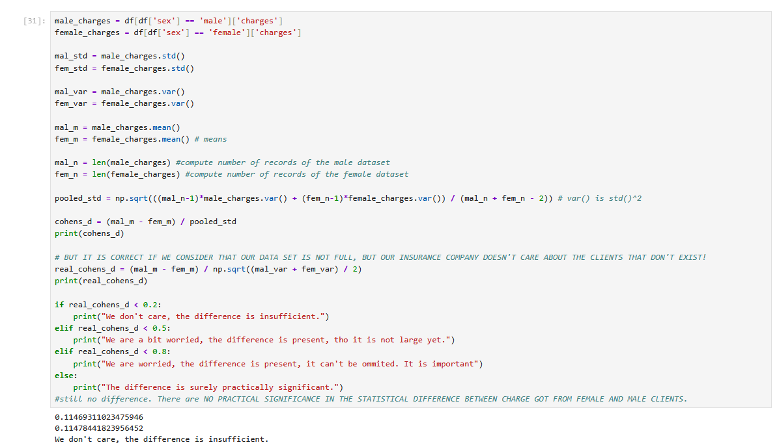
As we got previously, there are statistically important difference in charges from male and female clients. However, how cohen’s d suggests – we don’t care about it. It’s rather little.
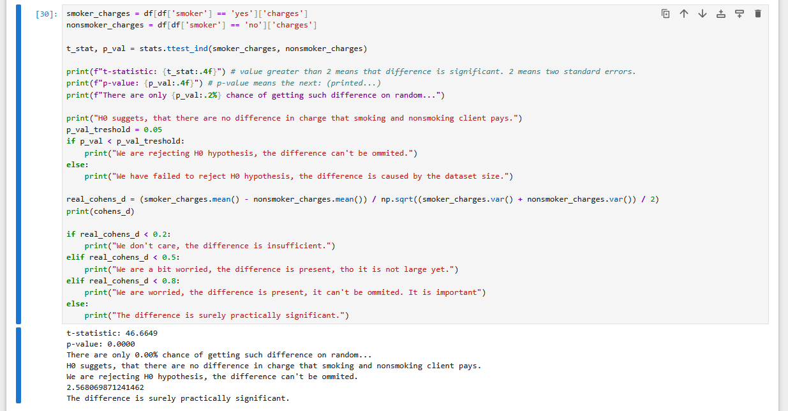
The difference between charge of smoking and nonsmoking clients is outstanding. And it is both statistically and practically significant.

7. Correlation & Visualization
- Scatterplot
- Correlation coefficient
- Interpretation (not just number!)

So as observed, the only good correlation we do have exists between age and charge. They do grow together, so the older client gets, the more client is charged for the insurance, however the correlation is pretty noise (as we got it is due to the is_smoking factor being absolutely practically significant)
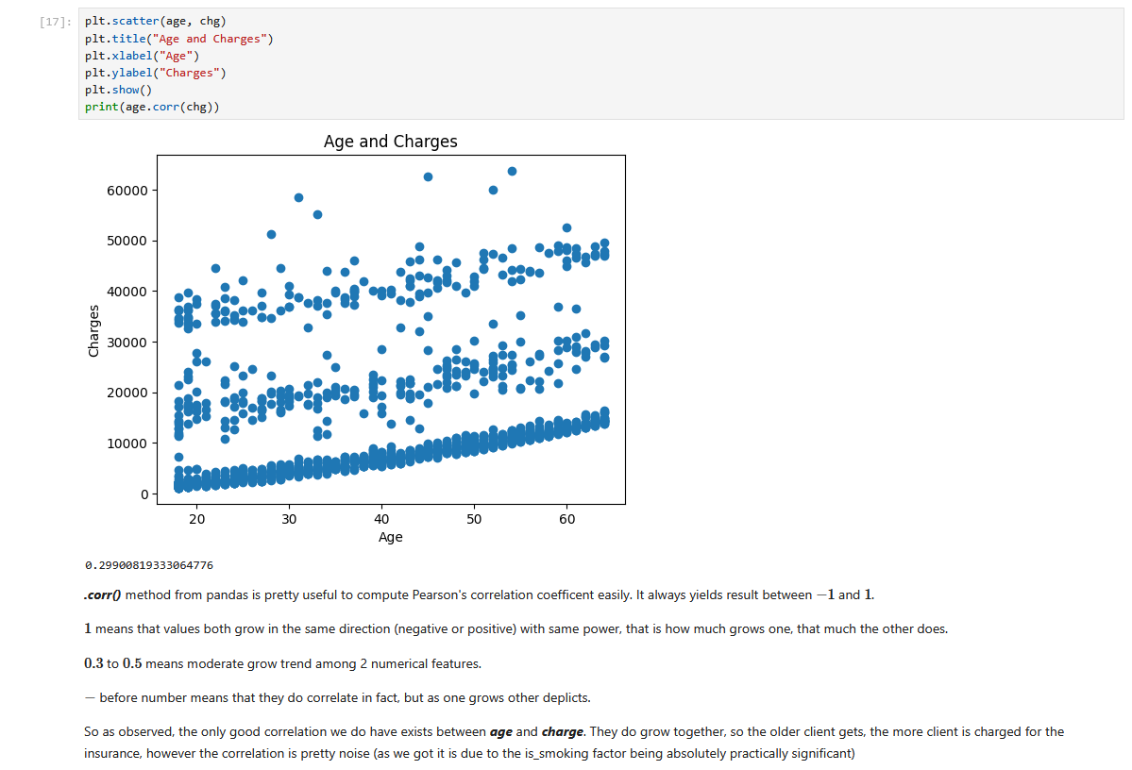

8. Regression Model
Choose one:
- Linear Regression
- Multiple Regression
Must include:
- Interpretation of coefficients
- R² explanation
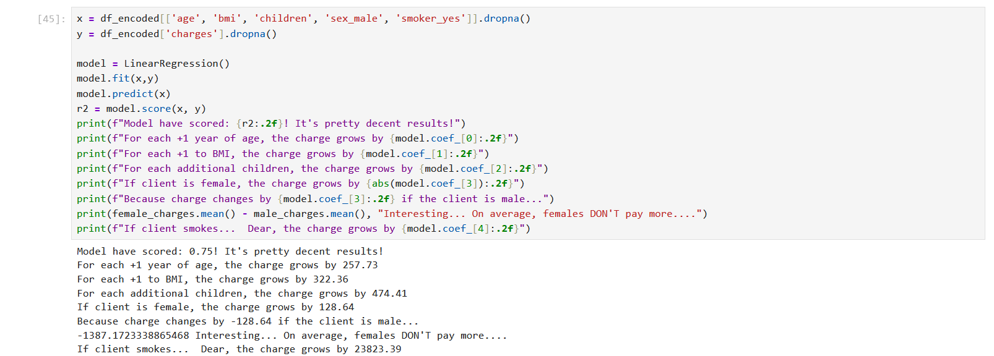
All the coefficents are explained on the screenshot.
Score of 0.75 means that model can explain 75% of the charges from clients, while the rest can be due to the region where they live or just a noise. 1.0 score is practically impossible, so the yielded one is pretty good.

9. Logistic Regression
- Binary outcome
- Interpret odds ratio
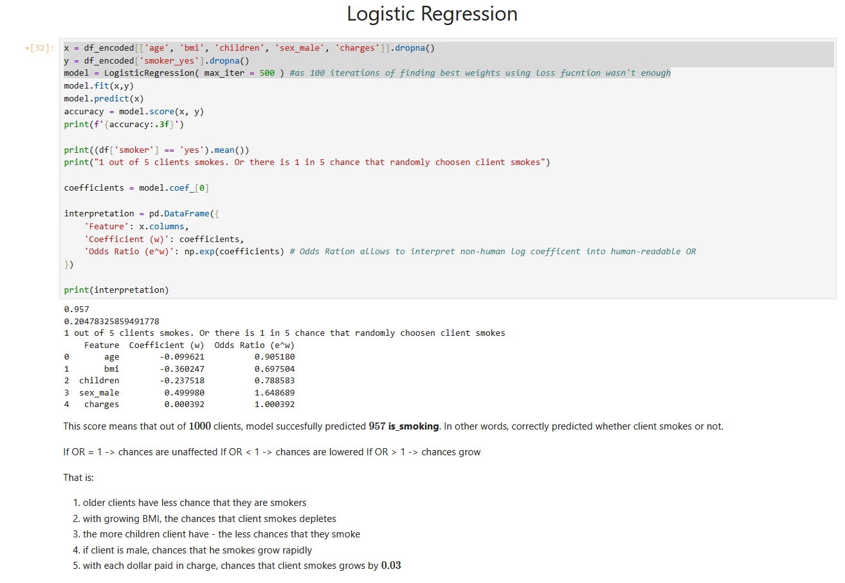

10. Model Validation
- Train-test split
- Overfitting discussion
- Residuals (if regression)
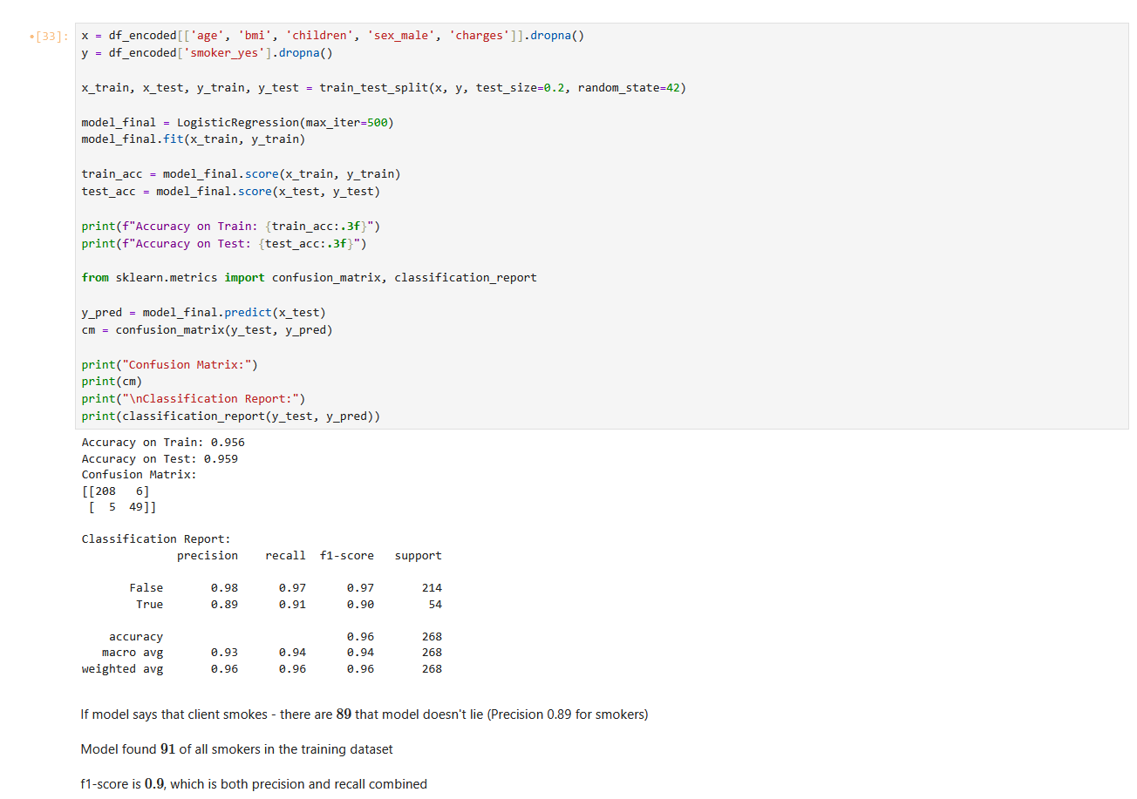

11. Model Comparison
- Compare at least 2 models
- Use metrics:
  - MSE / RMSE (regression)
  - Accuracy / F1 (classification)
For this I thought of creating 2 same models with different dateset’s columns, but as far as I got I have to compare MODELS, so I used random forest tree to classify smokers.
